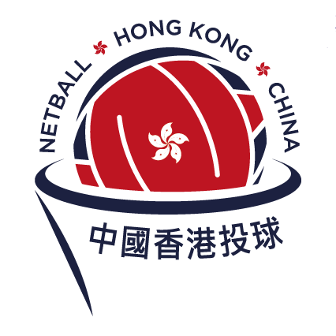
FORM A
REGISTRATION OF NETBALL TEAMS
2026-2027 SEASON

ONE FORM A TO BE COMPLETED PER CLUB / INDEPENDENT TEAM

- The completed Form A should be returned by 5pm Thursday 3rd September 2026 via email to:
nhkc@netball.org.hk. Any enquiries please direct to the above email address, or by calling 25048208 or via WhatsApp messenger at +852 9539 1288.

- Season 2026/2027 registration fee is HK$1,000 per team. A deposit of HK$600 per team is also payable. This deposit will be refunded at the end of the season if all League obligations are met, (this includes umpire duties and attendance of NHKC AGM).

- 2026/27 Season League games will be scheduled as early as 28th September 2026 and may run as late as March/April 2027 (depending on the number of teams entered and weather).

- Fees should be paid on or before 5pm 3rd September 2026 either via Bank Transfer or Faster Payment System (FPS) with the following account details:

Bank: HSBC Account Name: Netball Hong Kong, China Limited Email: nhkc@netball.org.hk

1. TEAM FEE A/C NO. 411-811375-001 HK$1,000 PER TEAM*

2. TEAM DEPOSIT A/C NO. 178-768966-001 HK$ 600 PER TEAM*

*Payer should be responsible for any bank charges involved in Bank Transfer and all the above fees should be paid in full to NHKC

- List all Teams and Grade requested below. Both Club and Single Independent Teams must complete all details.

- It is your Team/Club’s responsibility to fulfill your assigned umpiring duty (or arrange and pay a qualified umpire if your team/club does not have one). Failure to do so will incur penalty points and fines to that specific team.

- An Umpire Levy of $75 per umpire duty is payable to NHKC at the end of the season. Subsidies (to offset the umpire levy) are automatically applied as follows:
- 100% subsidy for teams providing two NHKC qualified umpires for their playing division by the end of the season
- 50% subsidy for teams providing one NHKC qualified umpires for their playing division by the end of the season

PLEASE PRINT CLEARLY:

Club/Team Convenor’s Name: ____________________________________________________________
Mobile: _______________________ Email: _______________________________________

Club/Team Umpiring Convenor’s Name: ___________________________________________________
Mobile: _______________________ Email: _______________________________________

Club /Team UNIFORM DETAILS and COLOURS
⬜ SHIRT ___________ ⬜ SKIRT/SKORT/SHORTS/DRESS _____________
⬜ BIBS_____________

Team Names in rank order | Captain’s Name & Phone No. |  | Division Requested | NHKC Division  (Office use)

