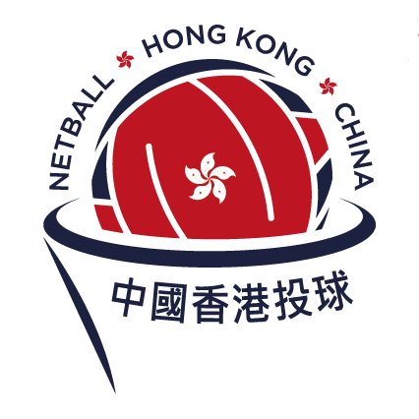

Netball Hong Kong, China Procedures and Criteria for Awarding Life Membership

- The Life Membership will be reviewed by all members of the Netball Hong Kong, China (NHKC) Executive Council and other Council Members.
- Any nomination for life membership should be made prior to 4th June 2026, a week before the Annual General Meeting held on 11th June 2026.
- The nomination can come from and seconded by any Association member.
- Once a nomination has been received by the President & NHKC Office, the Secretary shall have responsibility to circulate the information received on the nomination to all the NHKC Council Members. This should be done in conjunction with the nominator to allow time to gather the relevant information. A second special meeting may be held if necessary.
- While members not on the NHKC Council should be encouraged to provide information to such meetings, only the NHKC Executive and other Council Members should be present at the meeting or by proxy, unless the NHKC Council Members feel there are special circumstances requiring another person to attend. In such an event, this person should not be present when voting is undertaken.
- At the meeting to decide on the nomination/s all the NHKC Council Members shall, regarding the following criteria, determine if the nomination is worthy. The emphasis in this determination should be heavily on critical appraisal of the level of service to the Association required to be a Life Member. If there is any doubt of such a level being achieved, or lack of information about the nominee that makes such a conclusion impossible, then NHKC Council Members should consider voting in the negative.
- Criteria for consideration are as follows. There are four areas of service in the Association:
  - Playing
  - Coaching/Managing
  - Administration
  - General contribution (including fund-raising, supporting and other issues that Council may see as relevant)
The nominee must have an outstanding contribution in at least one of these areas and at least some contribution in two of the other three areas or contribution deemed appropriate at the discretion of the NHKC Council Members. In determining the level of significance, the NHKC Council Members should consider this in the light of a very high-quality service. While a reasonable length of time, at least 5 years, of service is important, the overall riding criterion is the quality of service.
- Once the nominator/sponsor has presented the information and all questions and comments have been made, the NHKC ExCom & NHKC Council Members shall conduct a secret ballot on the worthiness of the nomination.
- Should there be more than one nomination, then each should be considered in turn with a preliminary ballot to be taken (again secret) to determine which nomination is to take precedence. This preliminary ballot is NOT a vote of worthiness of the nomination against the criteria, but merely a way of determining which nomination should be the one to be voted upon.
- It is considered appropriate for either the President or Secretary to collect the votes. In the case of the need for a preliminary ballot the President / Secretary should count the votes and announce which nomination will be voted upon.
- In the unusual circumstance where there is a tied preliminary vote or the NHKC Council Members considers more than one nomination is worthy, the NHKC Council Members may determine that 2 life memberships are awarded. However, this must be only in extremely special circumstances, and no more than two can be awarded in any year.
- The President/Secretary should take the final votes and count them. Life members may only be voted on by a minimum of four ExCom Members or their proxies (who need to be Life Members), any Council Members who wish to vote with 80% of votes agreeing with the nomination. Given the importance of the decision, the attending NHKC Council Members are not allowed to abstain from voting.
- All the NHKC Council Members should be aware that it is not necessary for a Life Membership to be granted each year.
- The NHKC ExCom consists of the President, 2 Vice Presidents, Treasurer & Secretary. Other NHKC Council Members represent those members who were voted onto the Council at the AGM but do not hold an Executive Role.

